**T4 TABLE MODIFIED**

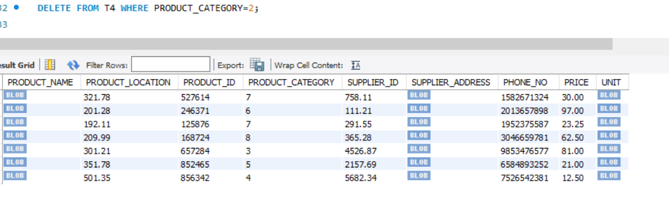

**T5 TABLE MODIFIED**

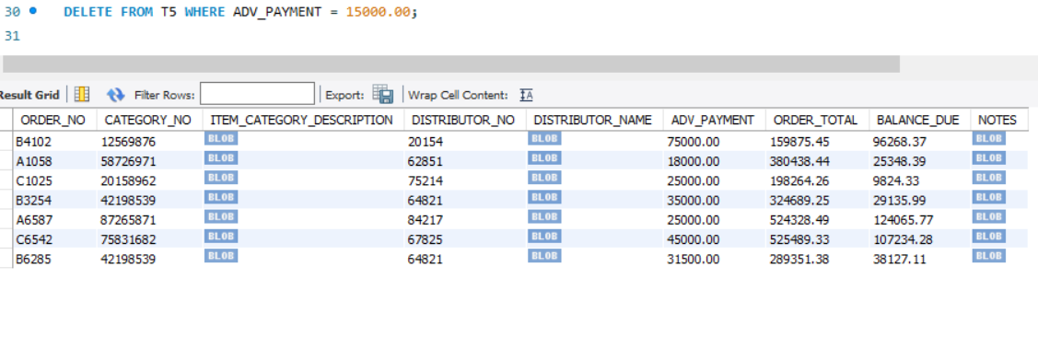

**TABLE 6 MODIFIED**

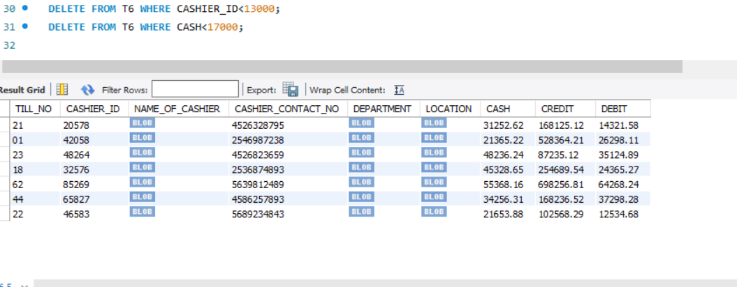

**TABLE 7 MODIFIED**

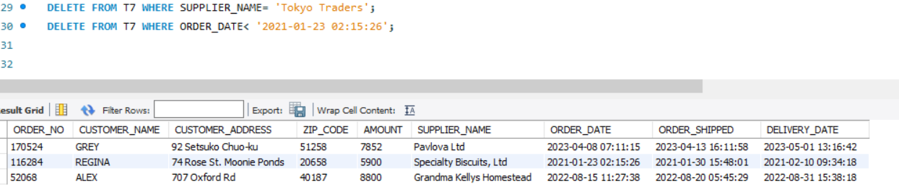

**TABLE 8 MODIFIED**

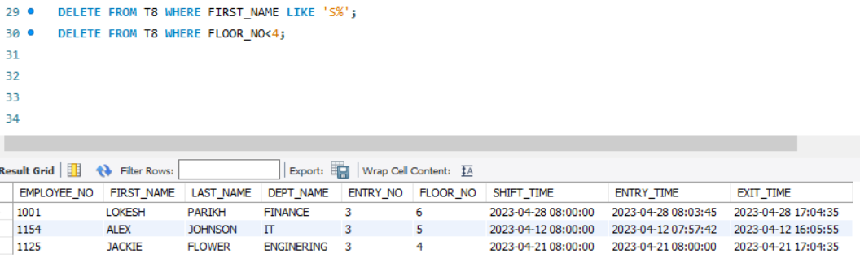

**TABLE 9 MOFIFIED**

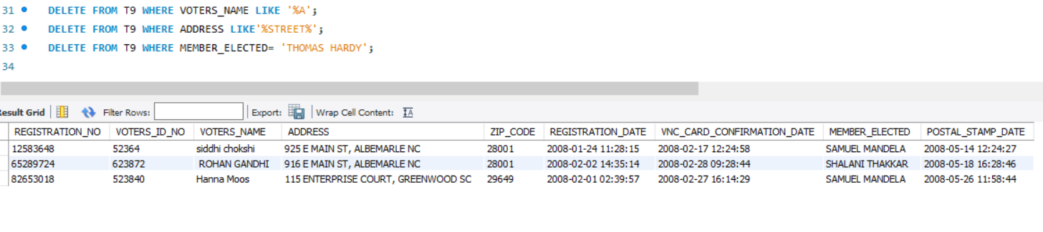

**TABLE 10 MODIFIED**

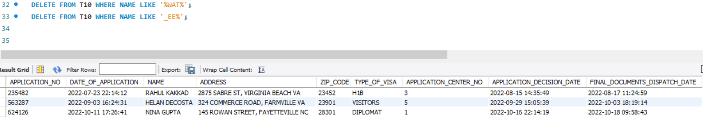

**TABLE 1 MODIFIED**

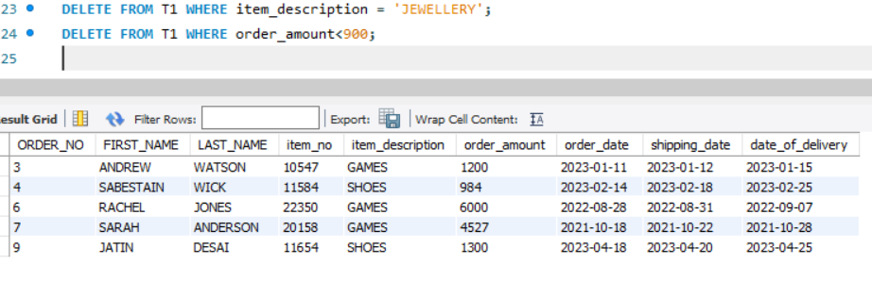

**TABLE 2 MODIFIED**

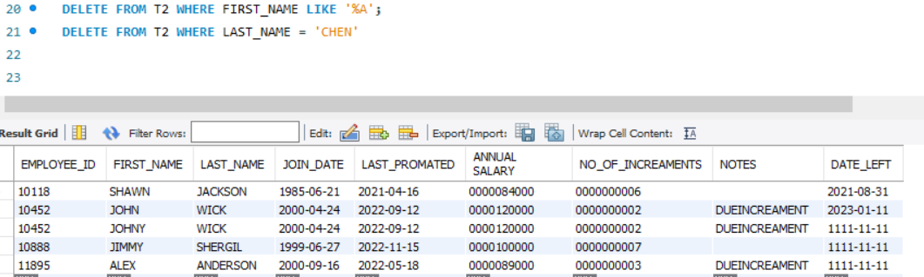

**TABLE 3 MODIFIED**

